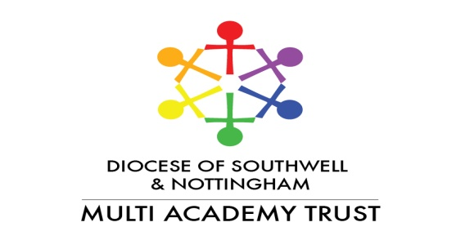

**Academy Improvement Officer: Secondment Opportunity**

**1 September 2025 – 31 August 2026**

This is an exciting opportunity for a senior leader to experience academy improvement work in a successful and thriving Trust.

SNMAT are looking for a senior leader to join their academy improvement team for a year’s secondment. During this time you will work alongside partner academies to help raise standards in all aspects of their work.

The successful candidate will promote and support the Trust’s Christian values.

Reporting to the CEO and the Academy Improvement Director, you will:

* Support a number of primary partner academies, liaising directly with the senior leaders and governors to establish and maintain positive and impactful relationships.
* Work alongside the CEO and Academy Improvement Director to drive improvements, contributing to the strategic development of the Trust.
* Design and deliver training for colleagues within the Trust.
* Analyse and evaluate outcomes data, reporting to the Board of Directors.

You will be able to demonstrate expertise in the primary phase of education, but may also be required to work in the secondary phase (although this will not be a significant part of the role). In addition, you will have a track record of success as a school leader.

The successful candidate will receive training and support to carry out the role, and will operate within the strongly collaborative ethos of the Trust. The role is largely based in partner academies, although there will be a regular requirement for work in our Southwell office.

All applicants must have secured the approval of their governing body.

Remuneration will match your existing salary, and travel expenses in line with our policy. This will be capped at L24 on the leadership scale.

This post is available to senior leaders across the sector.

**If you are interested in this exciting opportunity, please contact Chris Moodie on 07841 025000**

The job description and application form are available via the SNMAT website. <https://www.snmat.org.uk>

**Closing date: 28 April 2025**

**Interviews – 1 May**